Aussie Animal Colour-In
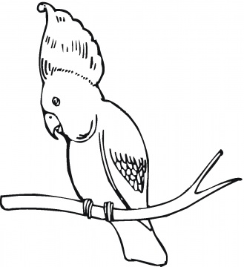
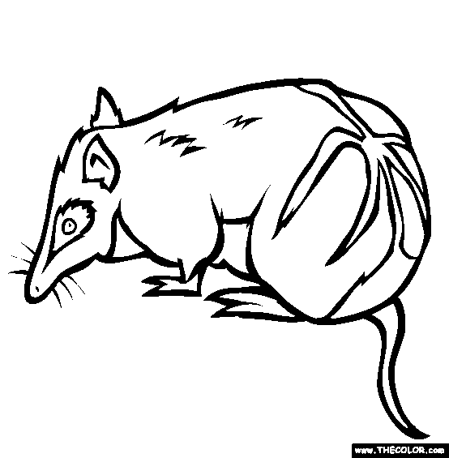

Bandicoot – My babies live
in my pouch!

Cockatoo – hear me squawk!

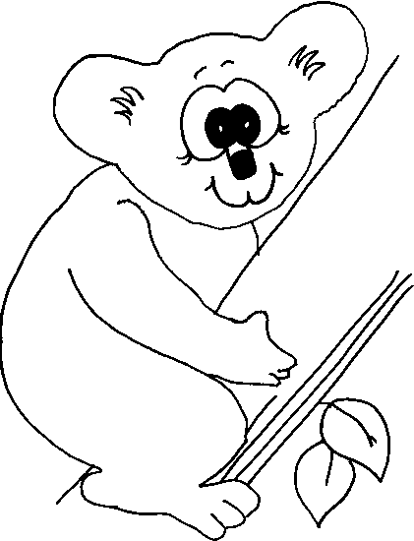

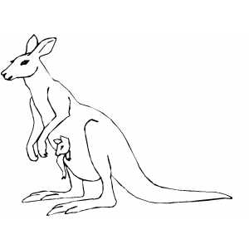
Koala – I love eucalyptus leaves

Kangaroo – watch me bounce!

Snake – tell an adult if you see me,
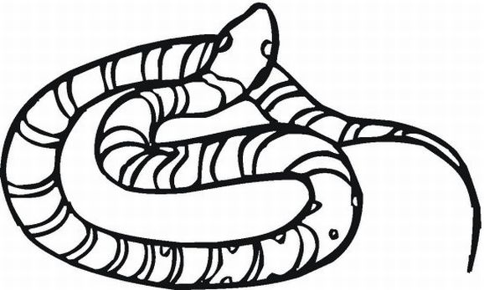
I may bite you!

Name: Age:

