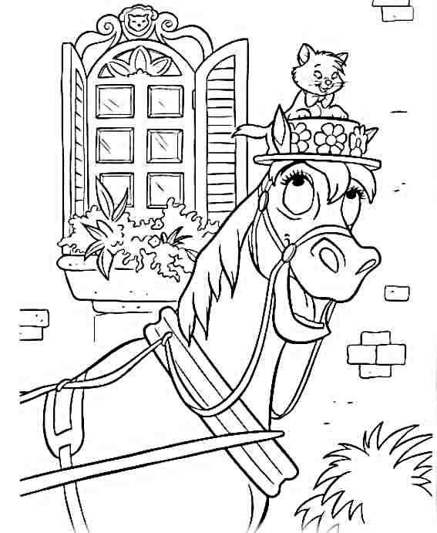

Name:
Age:
I love horses, but my other favourite animals are:

